Park App Design Document

DRAFT

|  |  |  |  |
| --- | --- | --- | --- |
| Date | Version | Author | Status |
| 05/12/16 | 0.1 | Ruth Awojobi | Active |
|  |  |  |  |
|  |  |  |  |

|  |  |  |  |
| --- | --- | --- | --- |
| **Version** | **Date** | **Author** | **Amendments** |
| 0.1 | 05/12/16 | Ruth Awojobi | Creation, Initial draft for review |
| **0.2** | **09/12/16** | **Ruth Awojobi** | **Continuation of Initial draft for review** |
|  |  |  |  |
|  |  |  |  |

|  |  |  |  |
| --- | --- | --- | --- |
| **Version** | **Date** | **Reviewed by** | **Comments** |
|  |  |  |  |
|  |  |  |  |
|  |  |  |  |

|  |  |  |
| --- | --- | --- |
| **Version** | **Date** | **Outstanding Issues** |
|  |  |  |
|  |  |  |
|  |  |  |

|  |  |  |
| --- | --- | --- |
| **Name** | **Date** | **Sign Off** |
|  |  |  |
|  |  |  |
|  |  |  |
|  |  |  |

Park App Design Document 1

1.0 Introduction 3

1.1 Purpose 3

1.2 Scope 3

1.3 Definitions and Abbreviations 3

1.4 Circulation 4

1.5 Assumptions 4

1.6 Risks 4

1.7 Dependencies 5

2.0 High-Level Architecture 5

3.0 Web Application Functionality and Design 5

3.1 Car Park (Landing Page) 5

3.1.1 Overview 5

3.1.2 Functional Requirements 5

3.1.3 Wireframe 7

3.2 Devices 9

3.2.1 Overview 9

3.2.2 Functional Requirements 9

3.2.3 Wireframe 10

3.3 Menu 12

3.3.1 Overview 12

3.3.2 Functional Requirements 12

3.3.3 Wireframe 12

4.0 Application wide Specifications 13

5.0 User Journey 13

6.0 Data Model 14

7.0 Process Flow 14

8.0 Appendix 15

# 1.0 Introduction

Being situated on a busy high street with parking restrictions; FSI’s staff and visitor parking spaces are very popular amongst its employees.

The FSI car park works on a first come first basis and all but the director spaces are available to all staff members. In the event where the company is expecting a/visitor(s), an email is sent the previous day to request the number of visitor spaces which are to be made available. In addition, due to the structure of the car park, there are occasional instances where employees need to be contacted to move their car in order to allow the person parked behind access to exit the car park. In these instances, an email is sent to ‘ALL UK STAFF’ requesting this.

In order to improve the aforementioned process, a new process was put in place, whereby, a white board representing a plan view of the car park for employees to write their details within the space in which they parked in order to be contactable directly (and to avoid sending emails to all).

## 1.1 Purpose

The aim of this Design Document is to provide a requirement documentation which will be used by an offshore development team to develop and ‘shelled’ carpark management Application (namely ‘Park App’) which can be accessed via a kiosk or mobile device.

This design document is intended to describe the functional requirements needed to develop this application in the form of User Stories (US) and UI design screens for the development of the Application. Each US will have a set of Acceptance Criteria’s (AC) which will assist with the write up of the test cases and form the basis for UAT to enable sign off of that particular US. Wireframes will be included to convey the desired look and feel of what is to be built, which then will be interpreted and designed by UX/UI developer to deliver the actual designs of what is to be built.

In addition to the UI/UX designs and US, the design document will also provide; User journey/ Screen navigations Process flows, data models, and workflow information to assist the offshore team in their work.

## 1.2 Scope

The scope of this document is to digitalise the current car park process and build a ‘shelled’ car park management application which allows FSI personnel to easily identify parking space availability as well as providing car park occupants contact information. A shelled application, otherwise known as an 'app in a wrap' is an application wrapping process whereby a management layer is applied to a web application without requiring any changes to the underlying application and means it would allow users to use the native features of their devices as they would with a native app on an android or iOS platform. In the first instance, development will look to fulfil the phase 1 core requirements further enhancements will be made to this web application in [**Phase 2/ 3**](https://fsifm.sharepoint.com/Enterprise%20FM/Shared%20Documents/Web%20Applications/Visitor%20Management/Requirements/Visitor%20Management%20User%20Stories.xlsx) after the successful completion of this phase.

## 1.3 Definitions and Abbreviations

* US –User Story
* AC –Acceptance Criteria
* EFM –Enterprise FM team
* Dreamscape – This is the platform upon which all web applications will be built

## 1.4 Circulation

* EFM team
* Any changes, update or amendments made to this document must be circulated to the author and agreed with Syl Omope.
* This document is the only living document for the duration of the project therefore, requirements contained herein are subject change in order to meet business needs.

## 1.5 Assumptions

* The application will have an option to access either as a guest or as an employee via username and password.
* Employee information will be accessible via a plug-in from the Data Object table within the dreamscape platform.
* The application can be accessed via a kiosk and/or mobile device.
* It is assumed that the team in place would be able to deliver this project within the set timeline.
* That the product that would be delivered will fulfil all of the phase 1 core requirements except where stated and will be fit for purpose.
* That the phase 1 Park App application is expected to be a stand-alone application and would not be dependent on any other back-end system

## 1.6 Risks

* This web application will be built by a new offshore team who are still developing their knowledge of the platform. This may impact the deliverables and delivery time for this project as they will require additional support during the development phase of this project.
* As the Dreamscape Platform would be used to build this Application, it should be noted that the functionalities requested, may not all be readily achievable based on the limitations of the platform.
* All requirements that cannot be included in this phase (Phase 1), would be estimated and included in the next phases (Phases 2/ 3).
* Encountering bugs and blockers in the Dreamscape Platform may cause delays in delivering this project on time.

## 1.7 Dependencies

None

# 2.0 High-Level Architecture

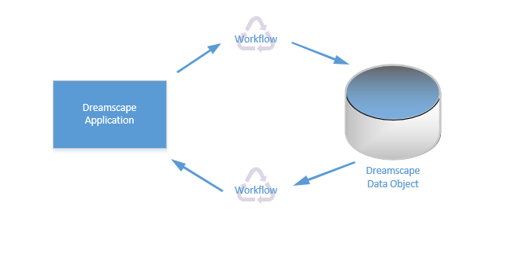

# 3.0 Web Application Functionality and Design

# 3.1 Park App-Kiosk

## 3.1.1 Overview

‘Park App’ is essentially a ‘one page’ application whereby the landing page will be the same page where all the interaction will take place. The application will be an animated plan of the car park with two ways a user can access the application; either via the kiosk as a guest or via a mobile device as a registered user. The following user stories narrates the requirements in the case where the employee or visitor accesses the application via a kiosk.

## 3.1.2 Functional Requirements

|  |  |  |  |  |  |
| --- | --- | --- | --- | --- | --- |
| **Theme** | **us-ID** | **As a/ an** | **I want to…** | **So that…** | **Acceptance criteria** |
| Kiosk | 001 | Employee | Log in as an employee | I can select which car park space I have parked in | * 2 Hardcoded buttons (‘Visitor’ and ‘Employee’) |
| Kiosk | 002 | Visitor | Log in as a Visitor | I can select which visitor car park space I have parked in | * 2 Hardcoded buttons (‘Visitor’ and ‘Employee’) |
| Kiosk | 003 | All Users | Be presented with an animated plan of the car park | I am able to notify others that my vehicle has occupied a particular car park space | * Animated plan of FSI’s car park * Permissions to be applied:   -User status: Visitor have entire car park greyed out except visitor bays  -User status: Employee entire car park view visible |
| Kiosk | 004 | All Users | Be able to select a clickable section within the car park plan | I am able to notify others that my vehicle has occupied a particular car park space | * Visitor will only be able to select spaces within visitor bays **(All visitor cars are ‘Green’)** * Employees will be able to select any space within the cells **(All employee cars are ‘Blue’)** |
| Kiosk | 005 | All Users | Be presented with a pop-up for me to insert my contact details | Other members of staff are aware of who parked where and my contact details are easily accessible when required. | * Pop-up to appear on click (or on selection of cell) * Visitors will need to fill out the textbox with following placeholder in text box:   -Name  -Number  -Registration   * First time employees will need to fill out the textbox with following placeholder in text box (once the information is filled out, the data will be added to the employee data object table):   -Name  -Number  -Registration   * Existing employees will have information already stored with an autocomplete function applied to each key stroke * Save button enabled once all fields are filled out * Screen navigates back to landing page |
| Kiosk | 006 | Employees | Be able to see a tick box to indicate a pool car | I can indicate that the car I’ve parked is a pool car | * Once the pool car tick box is selected, the registration field is grey out. * **All Pool cars are ‘Red’** |
| Kiosk | 006 | All Users | Be able to reselect a space already filled | I can override the information currently in the space I have actually parked in with the correct details or remove a vehicle no longer parked in the space selected. | * Pop-up to appear on click (or on selection of cell) with following placeholder in text box:   -Name  -Number  -Registration   * 2 Hardcoded buttons ‘Replace Car’ ‘Remove Car’ * Screen navigates back to landing page |
| Kiosk | 007 | All Users | Be able to edit my vehicle registration or contact details | I can ensure the correct information is displayed | * Pop-up to appear on click (or on selection of cell) * Existing employees will have information already stored with an autocomplete function applied to each key stroke * Phone number and Registration number fields are editable * Updated Phone number and Registration fields will override information previously stored * Save button enabled once all fields are filled out * Screen navigates back to landing page |
| Park App | 008 | System | Reset car park view at 12 midnight | The car park is free and ready to use the next day | * All parked cars are removed from the animated car park plan * System to loop around any vehicles flagged as ‘pool car’ |

# 3.2 Park App- Registered User

## 3.2.1 Overview

As well as being an open application, the ‘Park App’ will also have added functionality based on permissions when a registered user accesses the application using their credentials. The following user stories narrates the requirements in the case where an employee accesses the application using their credentials.

## 3.2.2 Functional Requirements

|  |  |  |  |  |  |
| --- | --- | --- | --- | --- | --- |
| **Theme** | **us-ID** | **As a/ an** | **I want to…** | **So that…** | **Acceptance criteria** |
| Mobile Device: (App in a Wrap) | 001 | Registered User | Be presented with an animated plan of the car park once the application icon is selected on my mobile device | I am able to notify others that my vehicle has occupied a particular car park space | * Animated plan of FSI’s car park |
| All Mobile Devices | 002 | Registered User | Be presented with an animated plan of the car park once my credentials have been inserted | I am able to notify others that my vehicle has occupied a particular car park space | * Animated plan of FSI’s car park |
| All Mobile Devices | 003 | Registered User | Be able to select a clickable section within the car park plan | I am able to notify others that my vehicle has occupied a particular car park space | * Selected cell automatically populated with user’s details * First time users will be presented with a pop-up giving the user the ability to insert his/her name, number and registration in the textbox fields |
| All Mobile Devices | 004 | Registered User | Be able to edit my vehicle registration or contact details | I can ensure the correct information is displayed | * Reselect space occupied by same user and be presented with a pop-up screen titled ‘Edit Contact Details’ * Phone number and Registration number fields are editable * Updated Phone number and Registration fields will override information previously stored * 2 Hardcoded buttons ‘Save’ ‘Remove Car’ |
| All Mobile Devices | 005 | Registered User | Be able to see a tick box to indicate a pool car | I can indicate that the car I’ve parked is a pool car | * Once the pool car tick box is selected, the registration field is grey out. |
| All Mobile Devices | 006 | Registered User | Be able to reselect a space already filled by another user | I can override the information currently in the space I have actually parked in with the correct details or remove a vehicle no longer parked in the space selected. | * Pop-up to appear on click (or on selection of cell) with following placeholder in text box:   -Name  -Number  -Registration  2 Hardcoded buttons ‘Replace Car’ ‘Remove Car’ |

# 4.0 Design Screens

The following screens represent the application UI when accessing it via a kiosk as a guest user or via a mobile (or desktop) as a registered user.

## 4.1 Kiosk

Screen 1 will be the landing page to the application (the application will always be redirected to this page after >5mins inactivity or when a user has concluded interaction with the application).

Screen 1

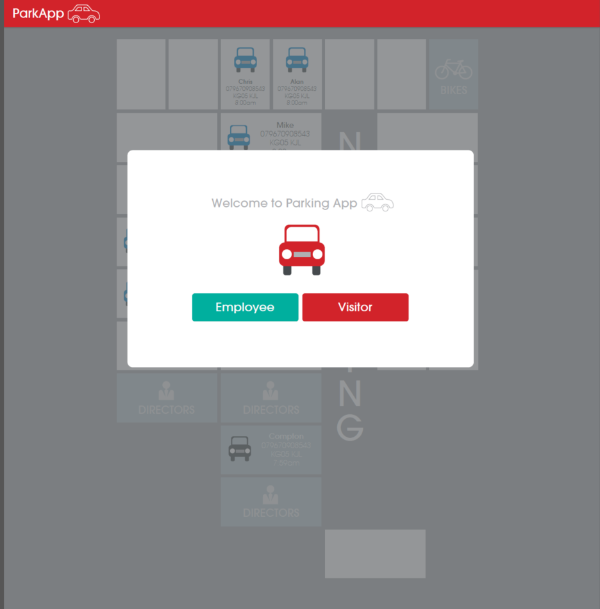

## 4.1.1 Kiosk- Employee

Screen E2 is an animated plan of the car park with clickable cells in which the user (in this case employee) can select to represent where their car is parked (the greyed out cells are unclickable). Screen E3 is a pop-up which will appear once the cell is selected whereby the user (employee) will be able to insert his/her name, number and registration in the textbox fields. In the case where this is a first time user, the system will store the information inserted. Users (employees) who have used the application before will be presented with the auto-complete once the user selects the correct name, the rest of the fields will be pre-populated and the application will navigate back to the landing page.

Screen E2 Screen E3

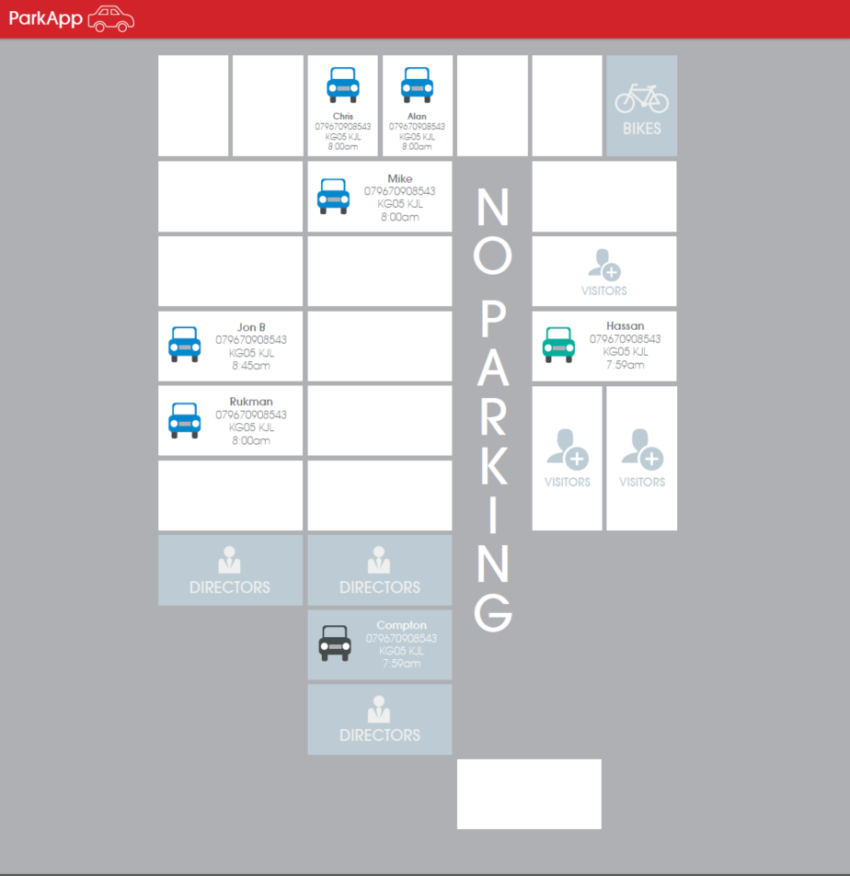 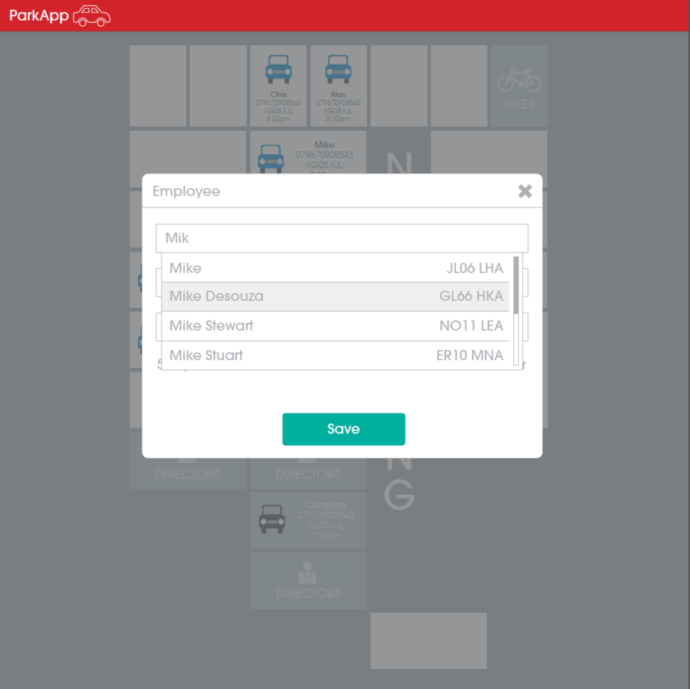

In addition to parking their own car, a user (employee) can also remove a vehicle or park a pool car. Screen E4 represents when a user is parking a pool car (the registration field is greyed out once the pool car tick-box is selected) whilst screen E5 represents an event where the user selects a pre-parked car and is presented with an option to ‘remove’ or ‘replace’ a car on click of either button.

Screen E4 Screen E5

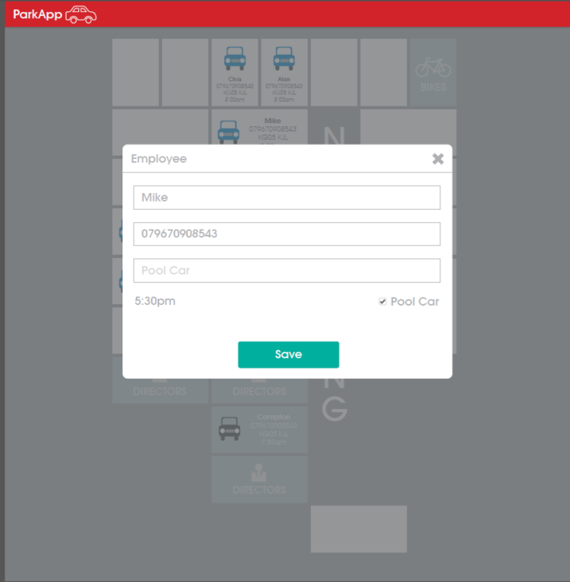 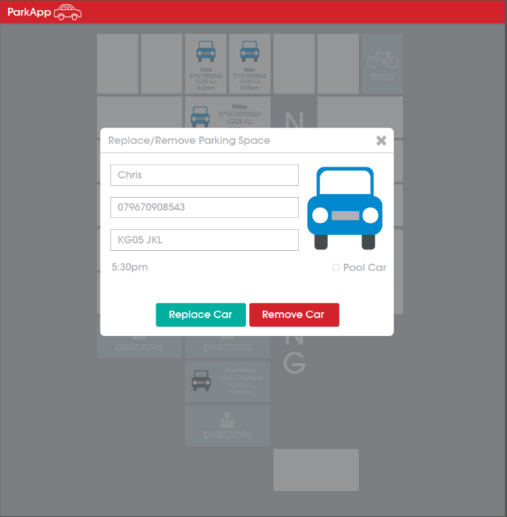

## 4.1.2 Kiosk- Visitor

Screen V2 is an animated plan of the car park with clickable cells in which the user (in this case a Visitor) can select to represent where their car is parked (the greyed out cells are unclickable). Screen V3 is a pop-up which will appear once the cell is selected whereby the user (visitor) will be able to insert his/her name, number and registration in the textbox fields (this information is never saved). Once the information is filled out, the application will navigate back to the landing page. Screen V4 is a pop-up which will appear once a ‘Visitor’ reselects a space already occupied and wishes to replace it with their information or wishes to remove the vehicle.

Screen V2 Screen V3

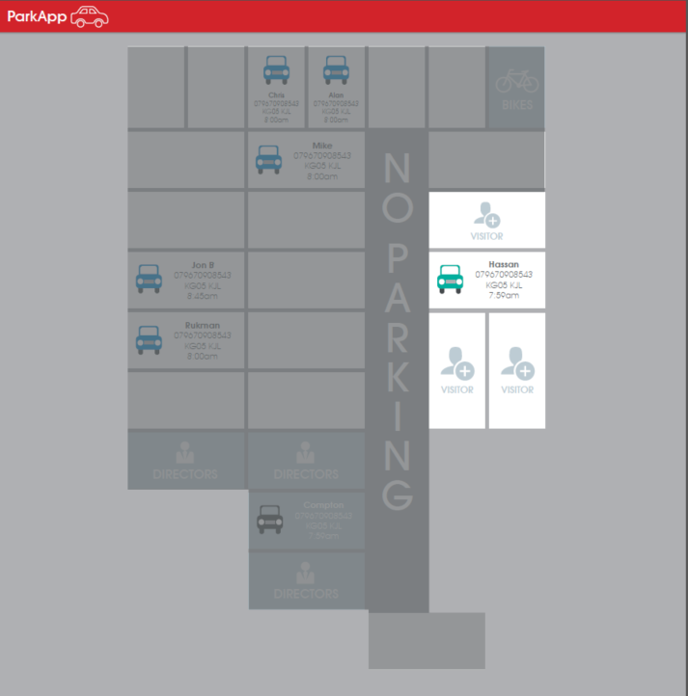 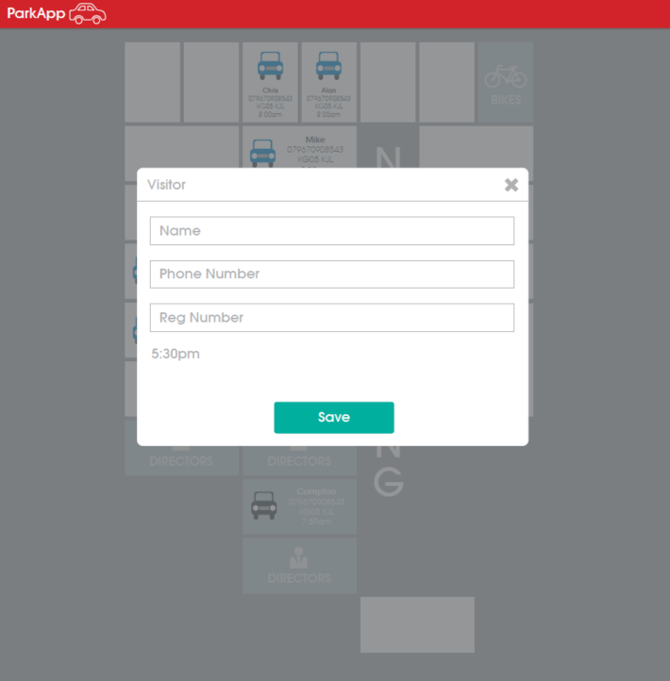

Screen V4

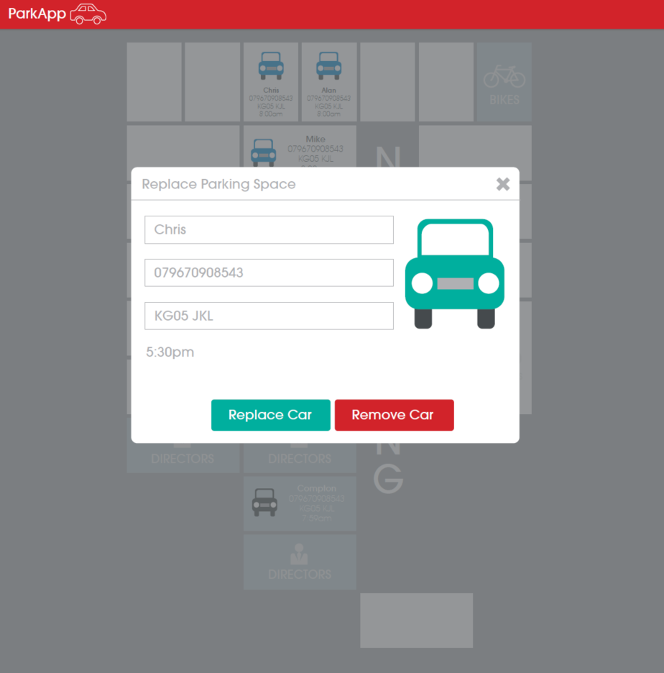

## 4.2 Registered User

When a user uses the ‘Park App’ from a device using his/her username and password, the user is instantly presented with screen ‘E2’ (animated carpark view). First time users will be presented with Screen R1 with the ability to insert his/her name, number and registration in the textbox fields. This information will be stored against the user’s profile and the user will not require filing out the field again. Once the user selects a blank space, his/her information is instantly placed on the cell selected. Screen E5 where a user selects a cell where another car is already in the space and the behaviour is identical to **4.1.1 Kiosk Employee** scenario. Screen R2 represents when a user reselects a parking space already occupied by same user. The user will have an option to ‘edit’ he/her information or ‘remove car’.

Screen R1 Screen R2

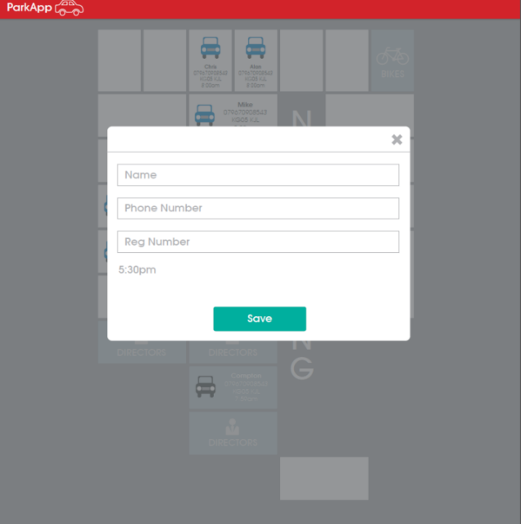 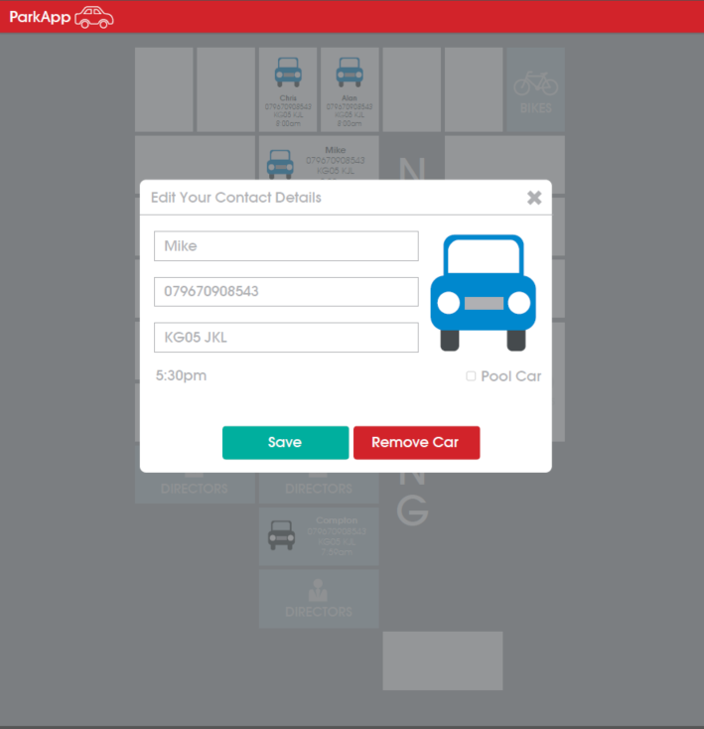

# 4.0 Application wide Specifications

Devices – This application is specifically designed to be used on mobile devices such as, Tablets and Mobiles (but can also be used on a desktop).

# 5.0 User Journey

## 5.1 Kiosk

The following user journey narrates screen flows once an employee or visitor interacts with the Kiosk version of the application

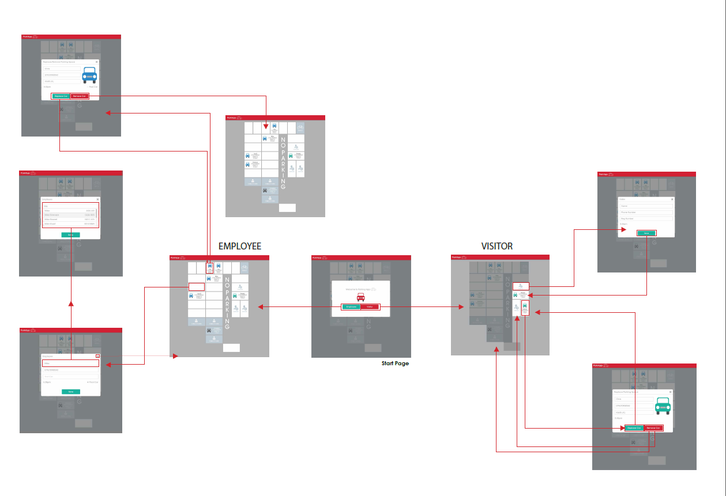

## 5.2 Registered User

The following user journey narrates screen flows once an employee uses his/her credentials to log onto the application via a mobile device (or desktop).

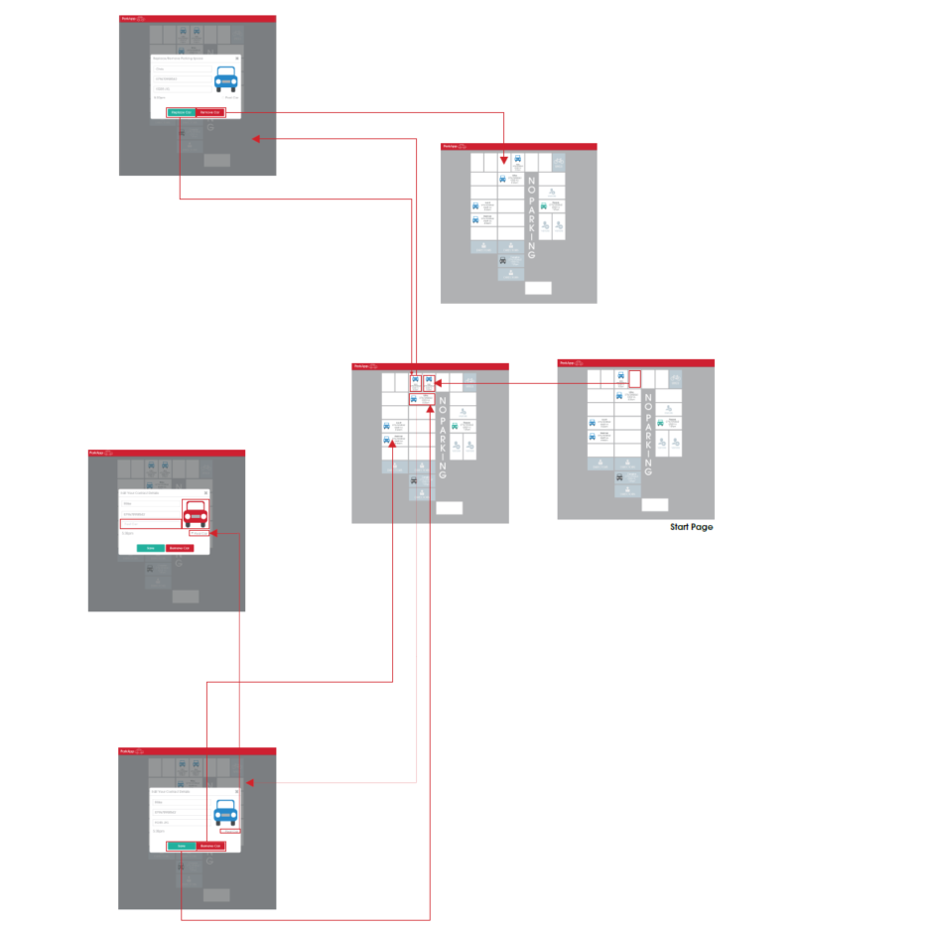

# 6.0 Data Model

TO BE INCLUDED

# 7.0 Process Flow

TO BE INCLUDED

# 8.0 Appendix